Akansha Chowdhury

Social Media Data Integration and Analysis using AWS Glue

EXTRACT, TRANSFORM, AND LOAD CERTIFICATION TRAINING
COURSE-END PROJECT-2

The AWS Console was logged in and the location was set to at North Virginia (USA)
The S3 bucket was created where the bucket name was used as etl-twitter-blog-15 (date of doing the project – 15/10/2025) in place of etl-twitter-blog as it was already used.
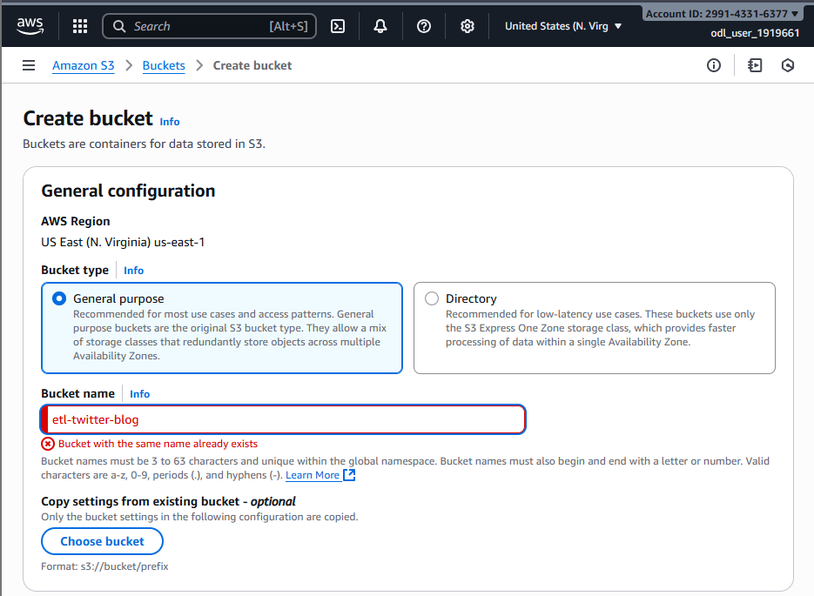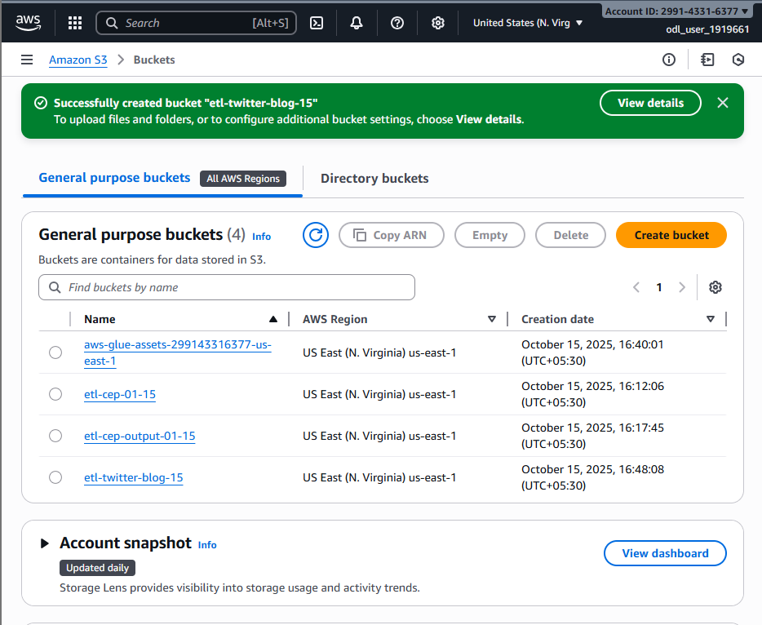
Next the two folders were made respectively etl-social-media and blog-data
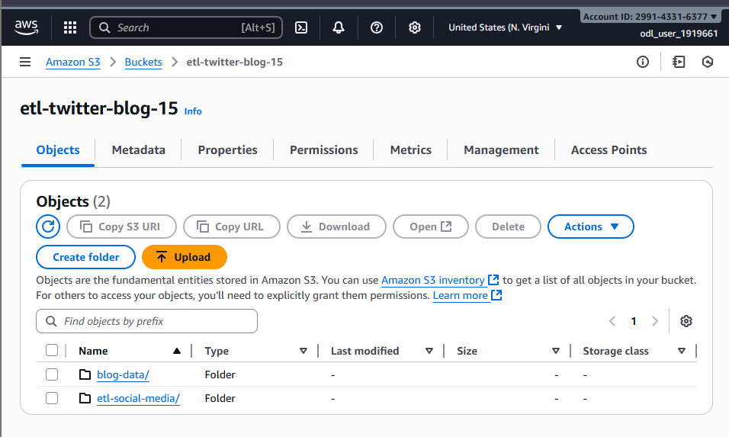
Inside those folders the files were uploaded
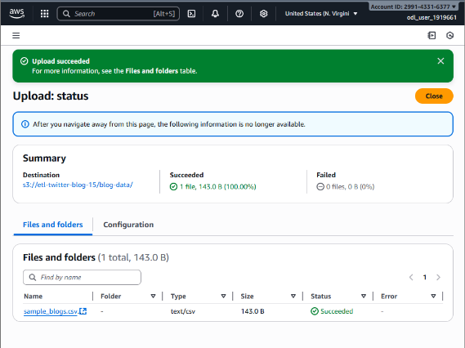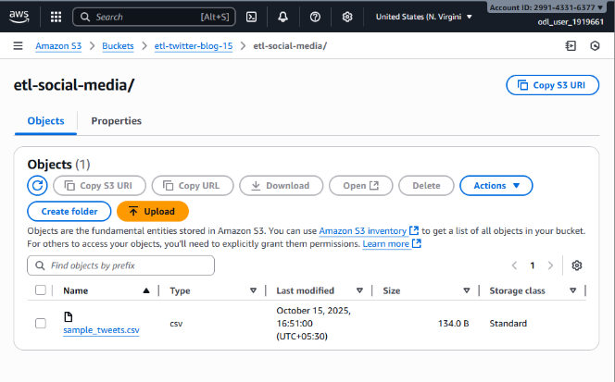

After that the next bucket was made and the name was changed as it said name already used. So, the new bucket was named etl-cep-output-15
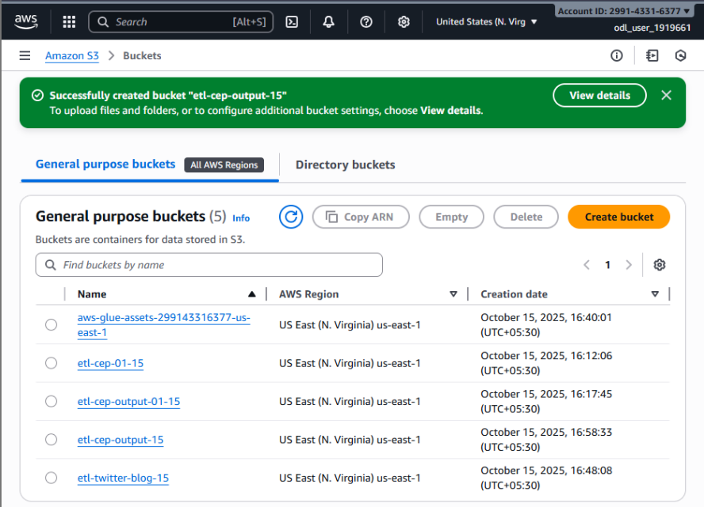
A new database was created social_media_data in the AWS Glue console
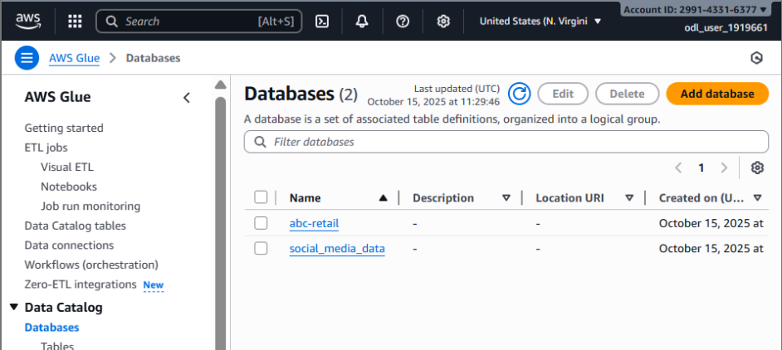
The two classifiers were created based on the give instruction twitter_data and blog_data
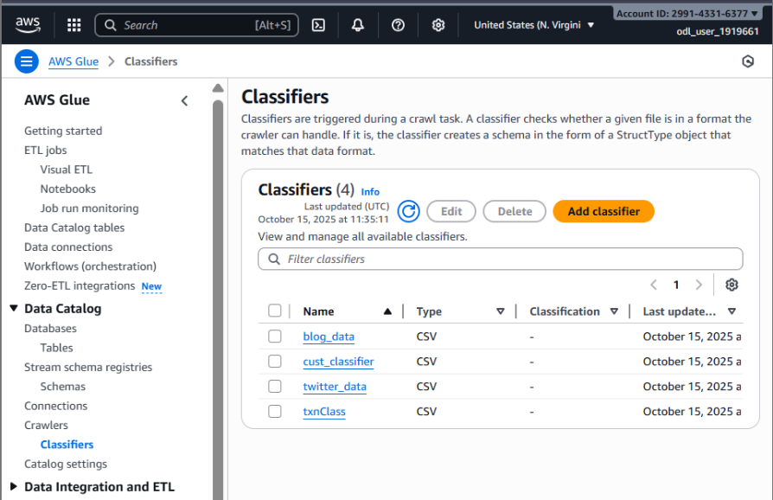
The new role was created in IAM role as glue-role
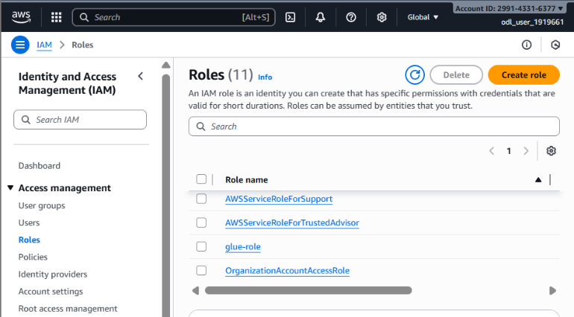
The Crawler was set up for both datasets and add to the database
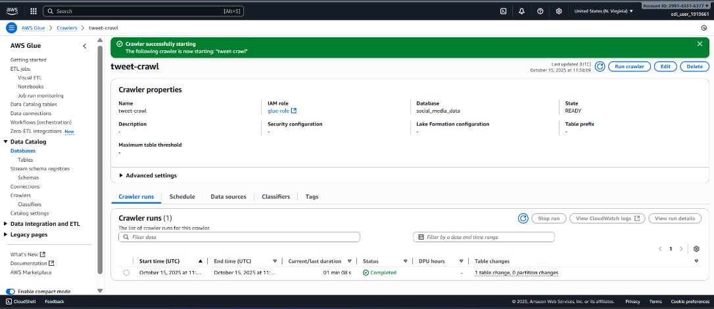
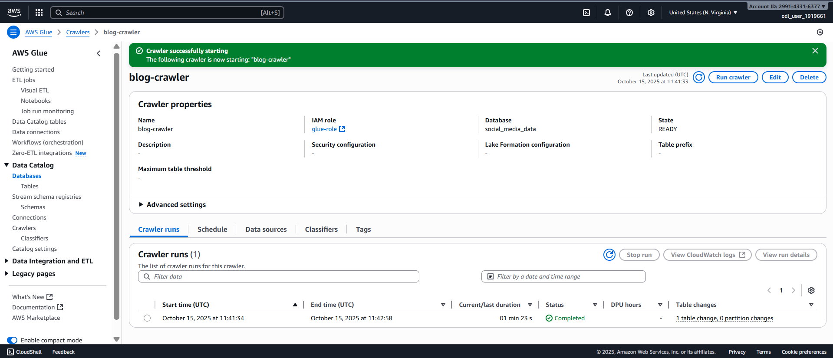
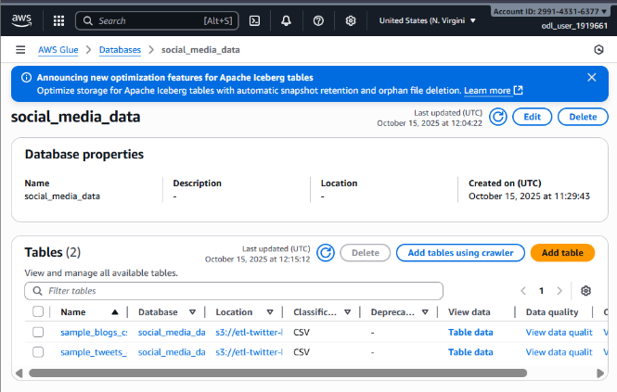
The ETL Job were created
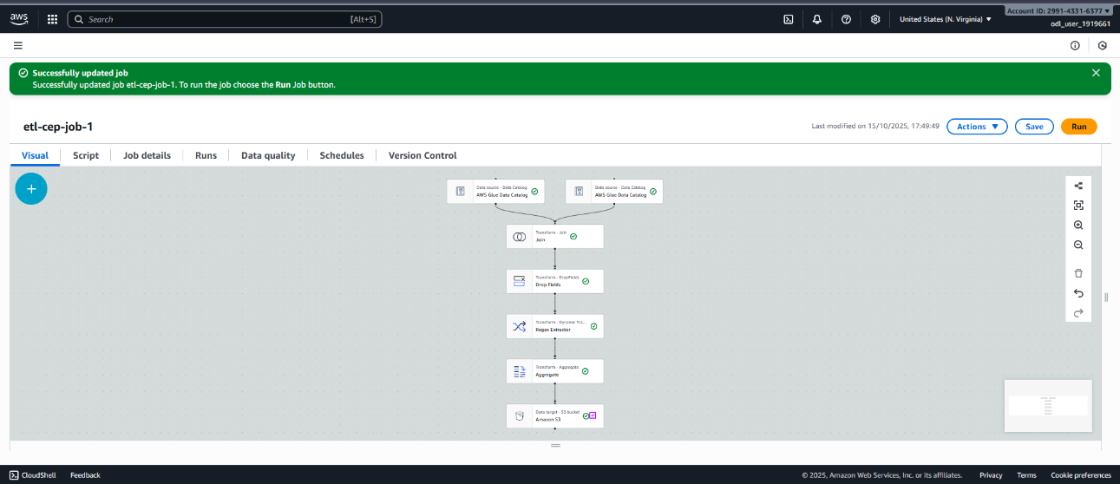
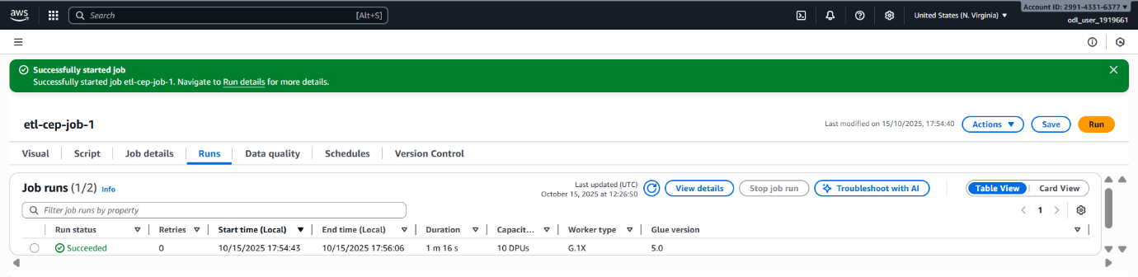
The output is given below
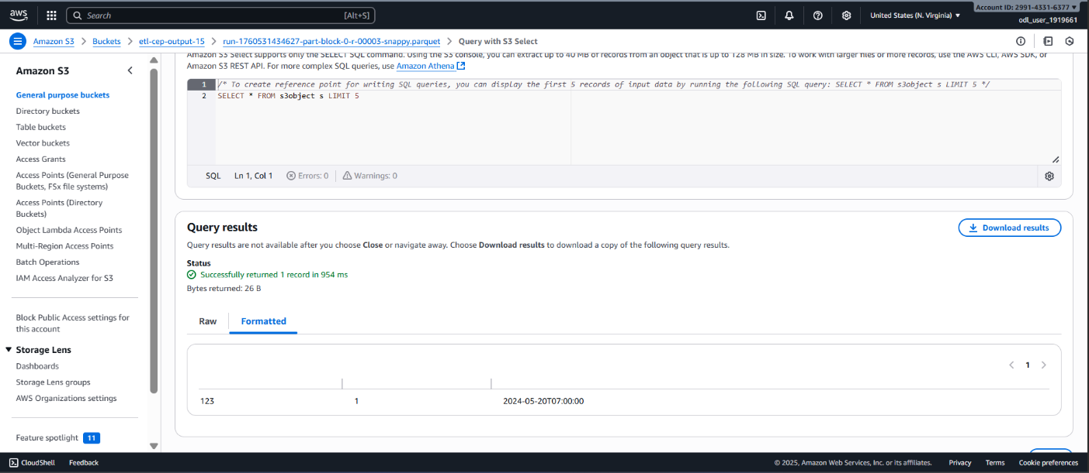
The output presented here has been obtained from the provided datasets.

